**TestNG Annotation and it’s internal order structure:**

**BeforeSuite 🡪 BeforeTest 🡪 BeforeClass 🡪 BeforeMethod 🡪 Test 🡪 AfterMethod 🡪 AfterClass 🡪 AfterTest 🡪 AfterSuite**

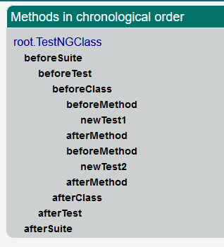

**N.B:** Here “@AfterSuite” runs at the end of all execution and in this code block we can keep the report which will be sent at email after running all test

If we have multiple **@Test**, every time this test will be start with **@BeforeMethod** and end with **@AfterMethod** individually.

**TestNG Class Code:**

public class TestNGClass {

@Test

public void newTest1() {

System.out.println("This is my first test : 1");

}

@Test

public void newTest2() {

System.out.println("This is my second test: 2");

}

@BeforeMethod

public void beforeMethod() {

System.out.println("This is :Before Method");

}

@AfterMethod

public void afterMethod() {

System.out.println("This is :After Method");

}

@BeforeClass

public void beforeClass() {

System.out.println("This is :Before Class");

}

@AfterClass

public void afterClass() {

System.out.println("This is :After Class");

}

@BeforeTest

public void beforeTest() {

System.out.println("This is :Before Test");

}

@AfterTest

public void afterTest() {

System.out.println("This is :After Test");

}

@BeforeSuite

public void beforeSuite() {

System.out.println("This is :Before Suite");

}

@AfterSuite

public void afterSuite() {

System.out.println("This is :After Suite");

}

}

**Above code Run result:**

This is :Before Suite

This is :Before Test

This is :Before Class

This is :Before Method

This is my first test : 1

This is :After Method

This is :Before Method

This is my second test: 2

This is :After Method

This is :After Class

This is :After Test

PASSED: root.TestNGClass.newTest1

PASSED: root.TestNGClass.newTest2

===============================================

Default test

Tests run: 2, Failures: 0, Skips: 0

===============================================

This is :After Suite

**Test Result Output:**

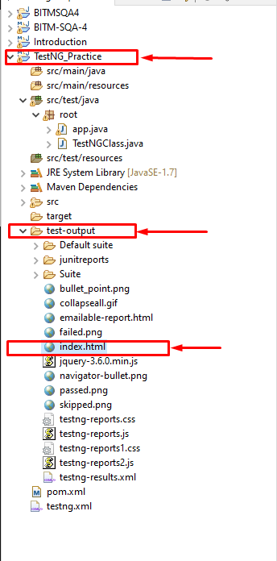

**This “Index.html file will open to a browser with the following result**

